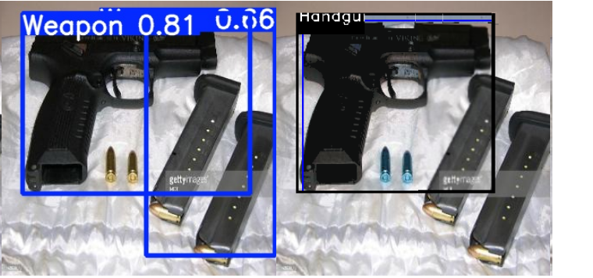 | YOLO false-positive detection (detection of confidence 0.66), rejected by classifier
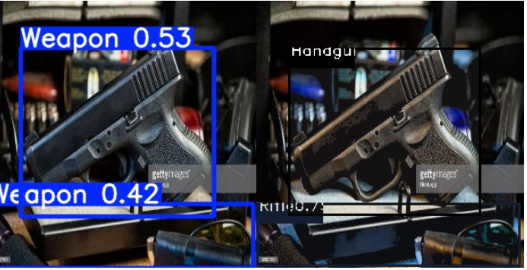 | YOLO false-positive (detection of confidence 0.42), accepted by classifier
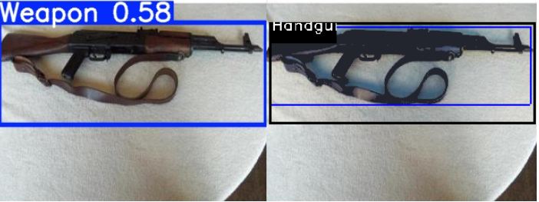 | Miss classify by 2nd stage
- Sample error patterns by proposed model on “weapon classification” reference dataset

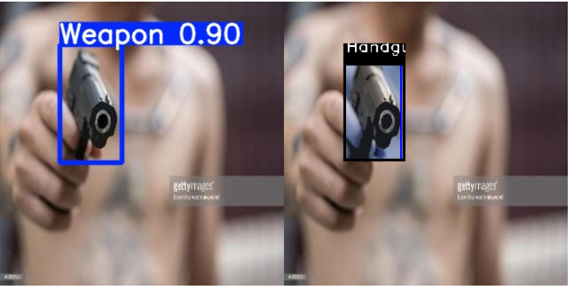 | Handgun
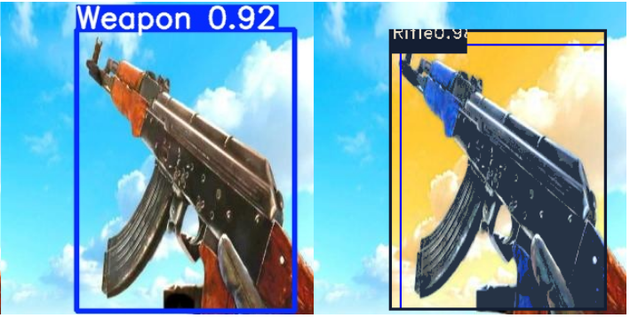 | Rifle
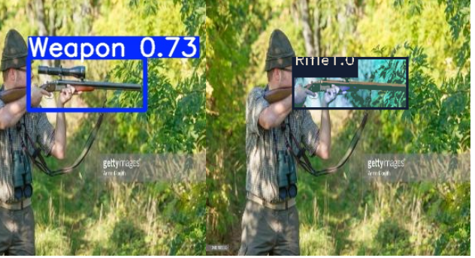 | Rifle
- Sample detection of proposed model on “weapon classification” reference dataset. Detections of different classes are shown as second stage output after passed by first satge as one class “weapon”

